**MINI PROJECT – UNIVERSAL PATIENT DATABASE**

**1) Problem Statement**

To build a common web based database system which needs to be used by all heathcare units (govt, pvt clinics and hospitals) in India for uniform patient data maintenance.

**2) DDB design**

EER DIAGRAM

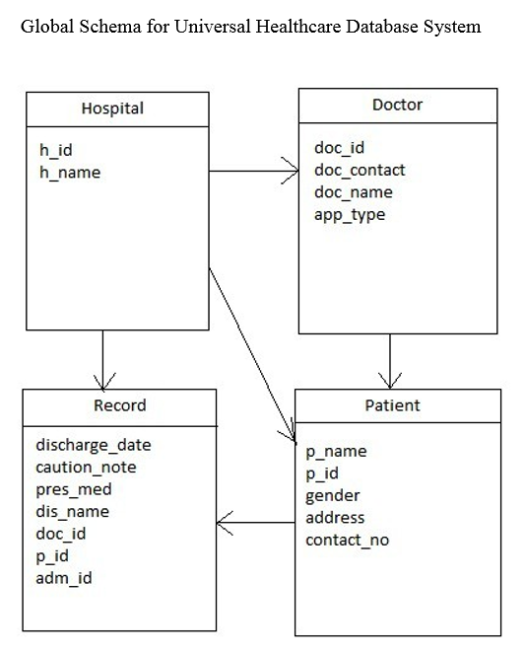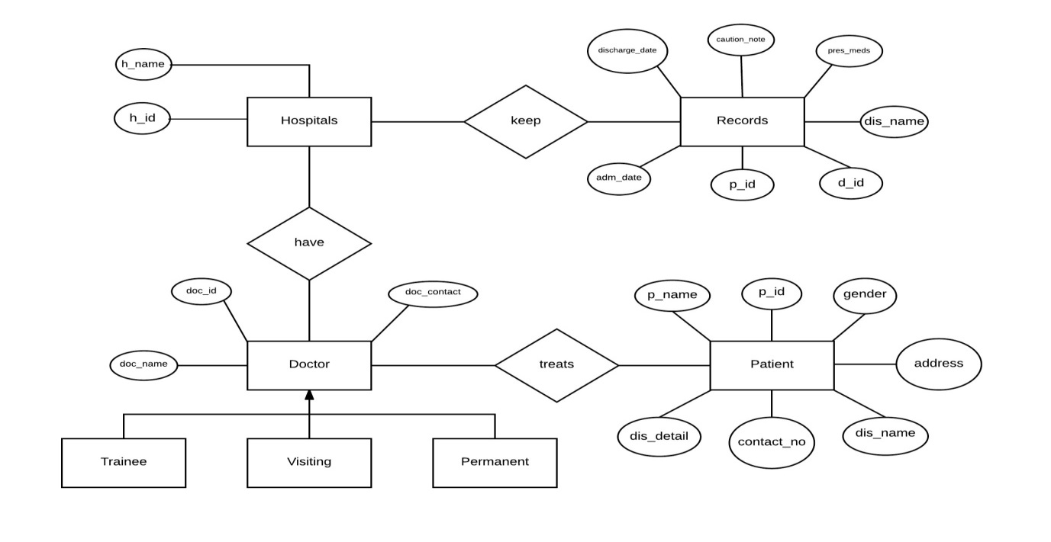

**3) Add data, fragmentation and other tasks:**

SQL*Plus: Release 11.2.0.1.0 Production on Sat Feb 18 14:30:35 2017

Copyright (c) 1982, 2010, Oracle. All rights reserved.

Enter user-name: d12c_b1@ddb_d12

Enter password:

Connected to:

Oracle Database 11g Enterprise Edition Release 11.2.0.1.0 - 64bit Production

With the Partitioning, OLAP, Data Mining and Real Application Testing options

SQL> show user

USER is "D12C_B1"

SQL> desc Doctor

Name Null? Type

----------------------------------------- -------- ----------------------------

H_ID NOT NULL NUMBER(38)

H_NAME VARCHAR2(20)

SQL> conn

Enter user-name: d12c_b18@ddb_d12

Enter password:

Connected.

SQL> create table Doctor1(h_id int primary key, h_name varchar(20));

Table created.

SQL> conn

Enter user-name: d12c_b24@ddb_d12

Enter password:

Connected.

SQL> create table Doctor2(h_id int primary key, h_name varchar(20));

Table created.

SQL> conn

Enter user-name: d12c_b1@ddb_d12

Enter password:

Connected.

SQL> create or replace trigger temp1 after insert on Doctor for each row begin i

nsert into Doctor1@P1link values (:new.h_id, :new.h_name); insert into Doctor2@D

link values (:new.h_id, :new.h_name);end;

2 /

Trigger created.

SQL> insert into Doctor values(1,'Ankita');

1 row created.

SQL> insert into Doctor values(2,'Ankit');

1 row created.

SQL> select * from Doctor

2 /

H_ID H_NAME

---------- --------------------

1 Ankita

2 Ankit

SQL> select * from Doctor1@P1link

2 /

H_ID H_NAME

---------- --------------------

1 Ankita

2 Ankit

SQL> select * from Doctor2@Dlink

2 /

H_ID H_NAME

---------- --------------------

1 Ankita

2 Ankit

SQL>

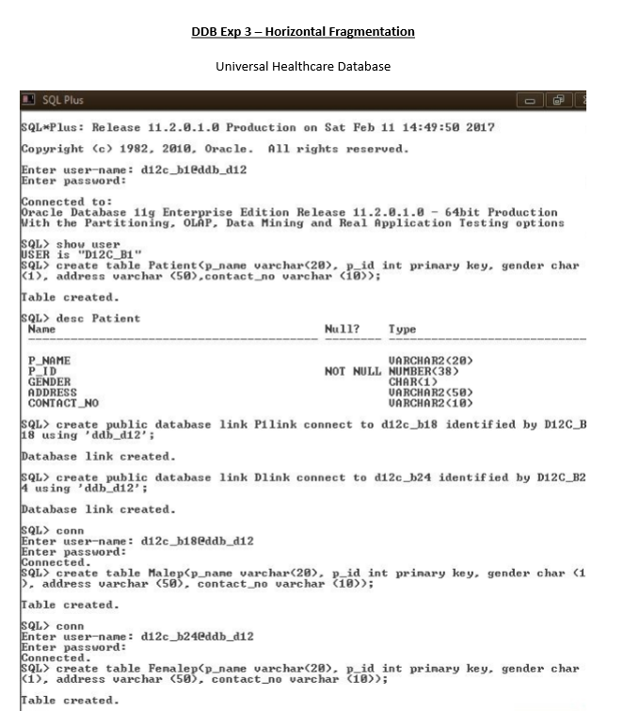

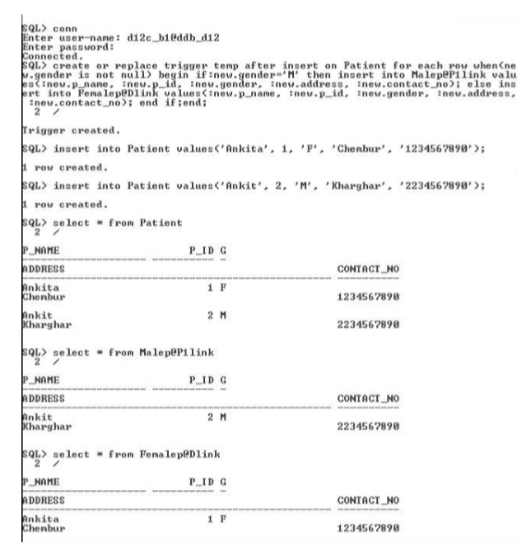

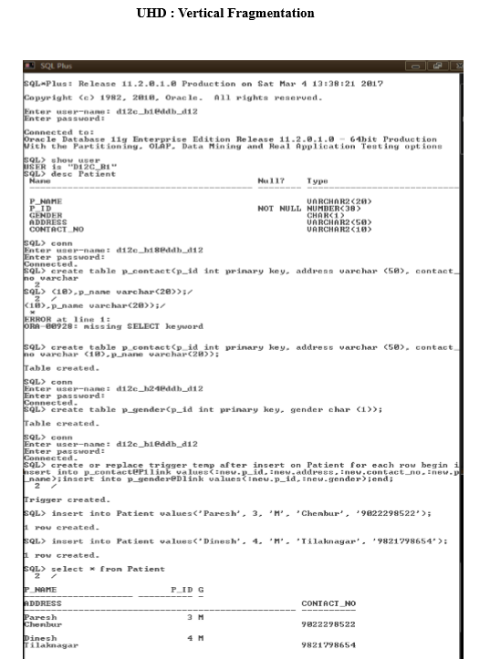

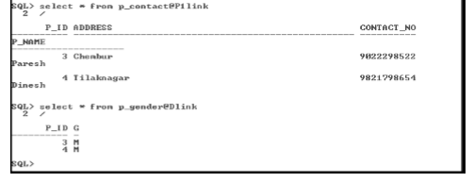

**PROJECT IMPLEMENTATION:**

Home Page:

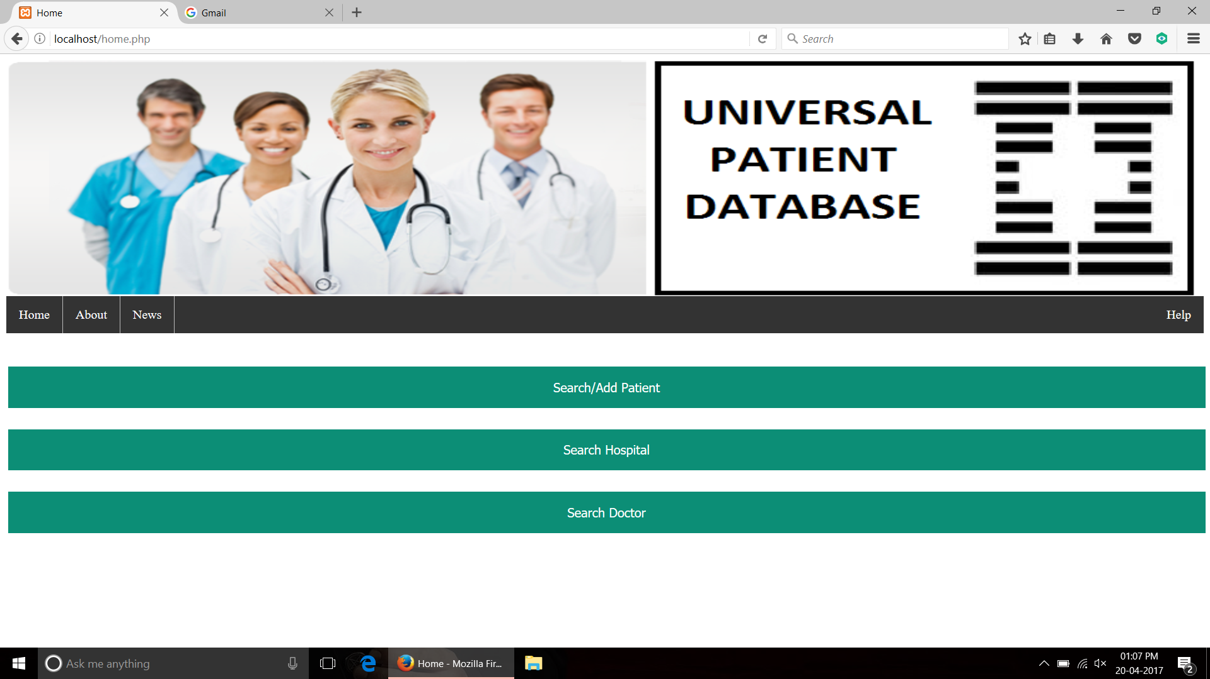

Search/Add Patient:

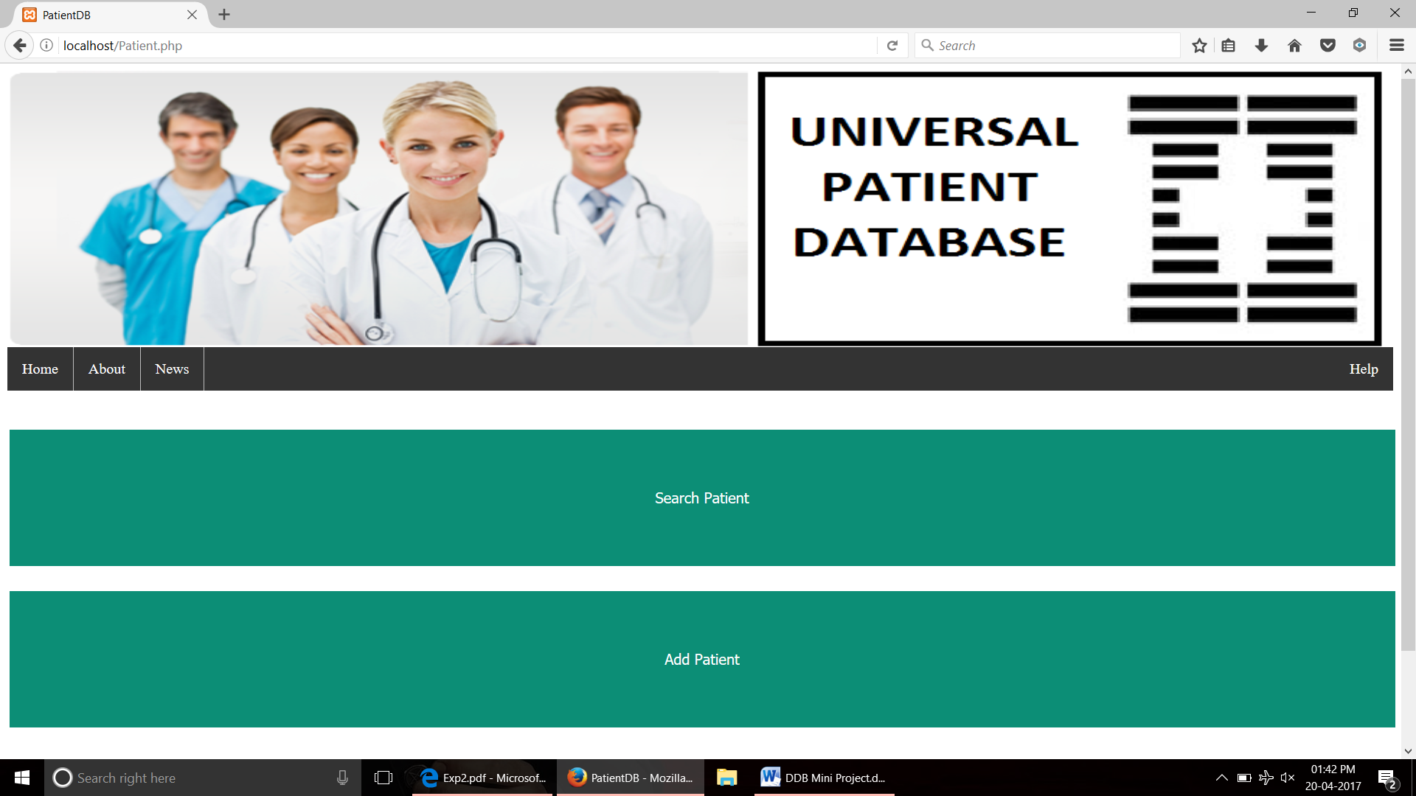

Search Patient:

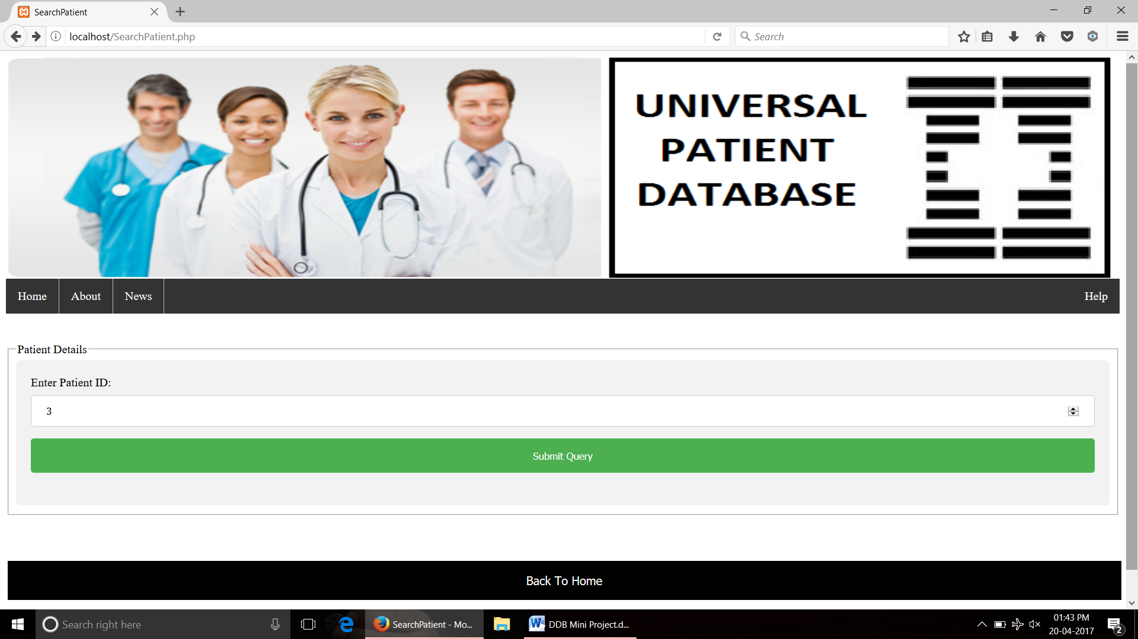

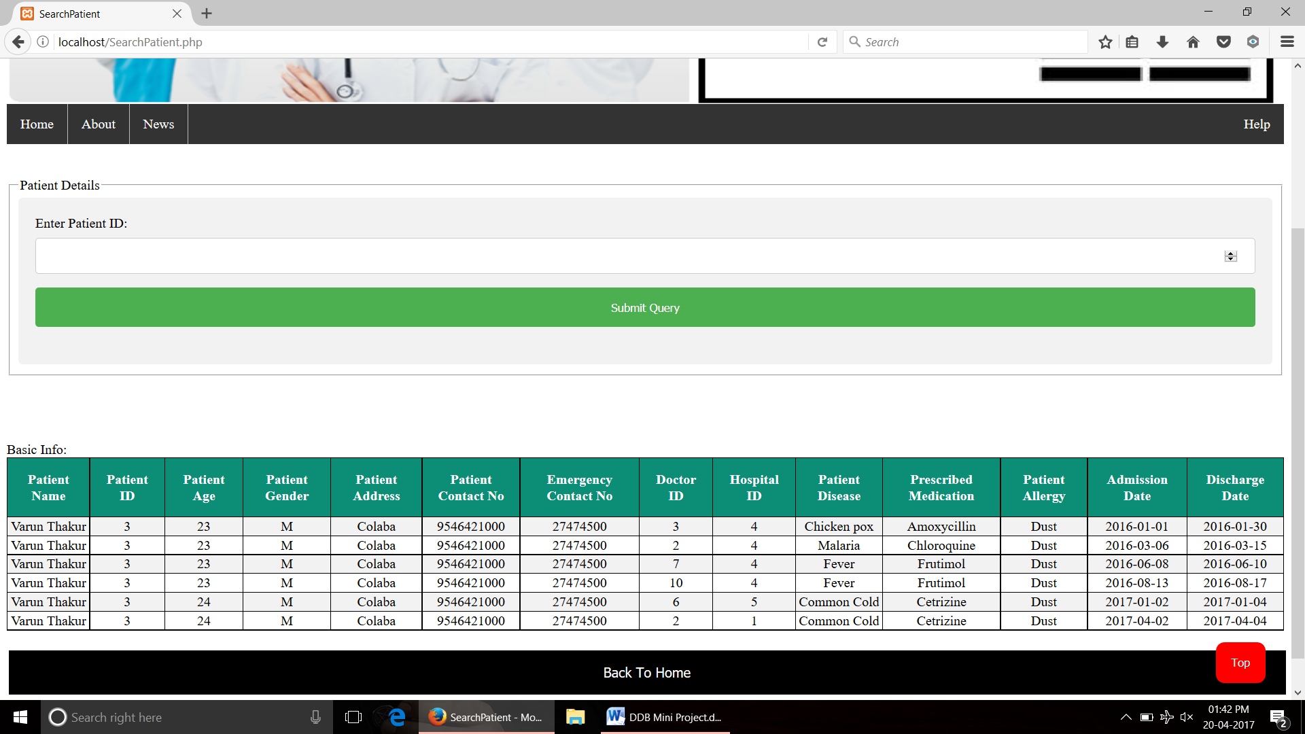

Add Patient: